Shashank Sarma
2019130053
TE COMPS
CSS Lab

Experiment 2

Aim:
To implement the Diffie Hellman Key Exchange Algorithm in Python.
Code:
P = int(input('Enter Prime Number P: '))
G = int(input('Enter Prime Number G: '))

a = int(input('Enter Private KeyA for Alice: '))
x = int(pow(G,a,P))

b = int(input('Enter Private KeyB for Bob: '))
y = int(pow(G,b,P))

ka = int(pow(y,a,P))

kb = int(pow(x,b,P))

print('The public key for Alice is: ',x)
print('The public key for Bob is: ',y)

print('Secret key for Alice is : %d'%(ka))
print('Secret Key for Bob is : %d'%(kb))

Output:
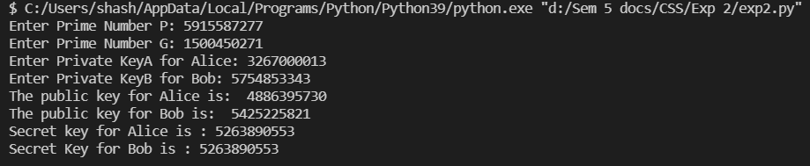
Conclusion:
Through this experiment, I learned about different types of key exchange algorithms and implemented the Diffie Hellman algorithm. My findings of the same are as follows:
The Diffie Hellman algorithm makes use of primitive roots of any prime numbers that are given by the user.
Since the exponentiation and modulo operation are used together in this algorithm, I had to write a custom power calculation function that accepts 3 numbers (namely the base, the power to which the number is supposed to be raised, and the modulo number) and calculates the power using the binary exponentiation algorithm in order to minimize the time complexity.
The beauty of this algorithm is that the secret key gets generated on both sides without exchanging the key. The key is calculated on both sides explicitly.

